HASH VALUES USING HASHCALC

**What is hash value**

A hash value is a unique numeric value that identifies data, such as a file, and is created using an algorithm. Hash values are often used in digital signatures because they can represent large amounts of data as smaller numeric values, which can be signed more efficiently.

A hash value is a string of characters and numbers that a hacker might not be able to read, keeping a person's information private.

**Hash function.**

The central part of the hashing process is the hash function. This function takes the input data and applies a series of mathematical operations to it, resulting in a fixed-length string of characters. The hash function ensures that even a small change in the input data produces a significantly different hash value.

Benefits of hashing

* **Data integrity.** Hashing is commonly used to ensure [data integrity](https://www.techtarget.com/searchdatacenter/definition/integrity). By generating a hash value for an amount of data, such as a file or message, a user can later compare it with the hash value of the received data to verify if any changes or corruption occurred during transmission.
* **Efficient data retrieval.** Hashing enables efficient data retrieval in hash tables, especially when dealing with large data sets. It uses functions or algorithms to map object data to a representative integer value. A hash can then be used to narrow down searches when locating these items on that object data map.
* **Digital signatures.** In addition to enabling rapid data retrieval, hashing helps encrypt and decrypt [digital signatures](https://www.techtarget.com/searchsecurity/definition/digital-signature) used to authenticate message senders and receivers.
* **Password storage.** Hashing is widely used for [secure password storage](https://www.techtarget.com/searchsecurity/post/Enterprise-password-security-guidelines-in-a-nutshell). Instead of storing passwords in plain text, they're hashed and stored as hash values. This adds an extra layer of security so even if the hash values are compromised, it's computationally infeasible to [reverse-engineer](https://www.techtarget.com/searchsoftwarequality/definition/reverse-engineering) the original passwords.
* **Cryptographic applications**. Hashing plays a crucial role in various cryptographic algorithms. Cryptographic hash functions are used to generate digital signatures, authenticate messages and ensure data integrity and authenticity. Hashing algorithms such as Secure Hash Algorithm 2, or SH-2, are widely used in cryptographic applications.

Disadvantages of hashing

* **Risk of collisions**. Hashing can sometimes suffer from collisions, which occur when two different inputs produce the same hash value. Collisions can lead to decreased performance and increased lookup time, especially if the number of collisions is high.
* **Key dependency.** Hashing relies on the uniqueness of keys to ensure efficient data retrieval. If the keys aren't unique, collisions can occur more frequently, leading to performance degradation.

HASH VALUE TYPES WITH EXAMPLE

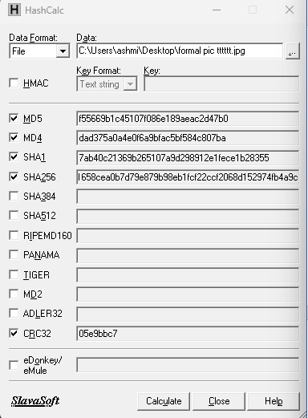

MD5 : f55669b1c45107f086e189aeac2d47b0

MD4 : dad375a0a4e0f6a9bfac5bf584c807ba

SHA1 : 7ab40c21369b265107a9d298912e1fece1b28355

SHA256 : 11a053c01cdecee41658cea0b7d79e879b98eb1fcf22ccf2068d152974fb4a9c

HASH CALC

HashCalc is a free-of-charge desktop utility that allows you to easily calculate hashes, checksums, and HMAC values for texts, hex strings, and other file types.

HashCalc is a program that creates a hash for a file using various hashing algorithms, such as SHA, SHA1, SHA256, SHA384, SHA512, MD4, and MD5. It can also create a HMAC hash, which is a "Hash Method Authentication Code" based on text entered by the user.

Why SHA 256

SHA256 has several advantages over MD5 and SHA-1, such as producing a longer hash (256 bits) that is more resistant to collisions and brute-force attacks. Additionally, there are no known vulnerabilities or weaknesses with SHA256, unlike MD5 and SHA-1 which have been exploited by hackers and researchers.

Sha 256

HASH VALUE OF ORIGINAL FILE

df52eaadea34ba1439731571a396407b9e730f98da7ef8ba38954ba962592336

HASH VALUE OF THE FILE AFTER RENAMING

df52eaadea34ba1439731571a396407b9e730f98da7ef8ba38954ba962592336

HASH VALUE OF THE FILE AFTER MODIFICATION

c1a5da61f4d7bf0a54a13bfdc0a9dfe474bfbe793449d5a722b8cd8a93e1da99

HASH VALUE OF THE FILE VERSION 2 (word-pdf)

9b0728fd56829504b40cf68a1e458481a3cce152ac4380292333adc04a8b17ca

HASH VALUE OF THE FILE AFTER SHARING THROUGH WHATSAPP (pdf)

9b0728fd56829504b40cf68a1e458481a3cce152ac4380292333adc04a8b17ca

HASH VALUE OF IMAGE

11a053c01cdecee41658cea0b7d79e879b98eb1fcf22ccf2068d152974fb4a9c

HASH VALUE AFTER SHARING THROUGH WHATSAPP

11a053c01cdecee41658cea0b7d79e879b98eb1fcf22ccf2068d152974fb4a9c

HASH VALUE AFTER SHARING THROUGH EMAIL

11a053c01cdecee41658cea0b7d79e879b98eb1fcf22ccf2068d152974fb4a9c

HASH VALUE AFTER SHARING THROUGH TELEGRAM (without compressed)

11a053c01cdecee41658cea0b7d79e879b98eb1fcf22ccf2068d152974fb4a9c